**Sem: V Academic Year: 2024-25 Date:**

**DBMS&QP LAB MINI PROJECT SYNOPSIS**

**Title:** Transport Management system

**Abstract:**

The Web-based Transport Management System (TMS) is an integrated platform designed to optimize and automate the various aspects of transportation operations within an organization. This system will simplify the management of vehicle scheduling, driver assignments. By providing an intuitive web interface for fleet managers, drivers, and administrators, the TMS aims to enhance operational efficiency, reduce costs, improve fleet utilization, and minimize manual processes. The project seeks to offer a centralized solution for managing all transportation-related activities, promoting seamless coordination and real-time monitoring.

**Description of Modules:**

1. Authentication Module:

User login and logout functionality

User sign up

Password change feature

2. vehicle Module:

Vehicle management

Availability of vehicle

3. driver Module:

Profiles of drivers

4. user Module:

User management (add, update, delete users)

user details update

5. home Module:

View bookings, book a car,update profile

**Tools to be used:**

Front End tools:

Html5 , css , javascript

Back End tools:

PHP

Xampp

**Team Details:**

|  |  |  |  |
| --- | --- | --- | --- |
| **Sr.No** | **Roll No** | **Name of Student** | **Signature** |
| 1 | 22CE13 | Daanish Toragall |  |
| 2 | 22CE17 | Elizabeth Joseph |  |
| 3 | 22CE19 | Gargi Sardessai |  |

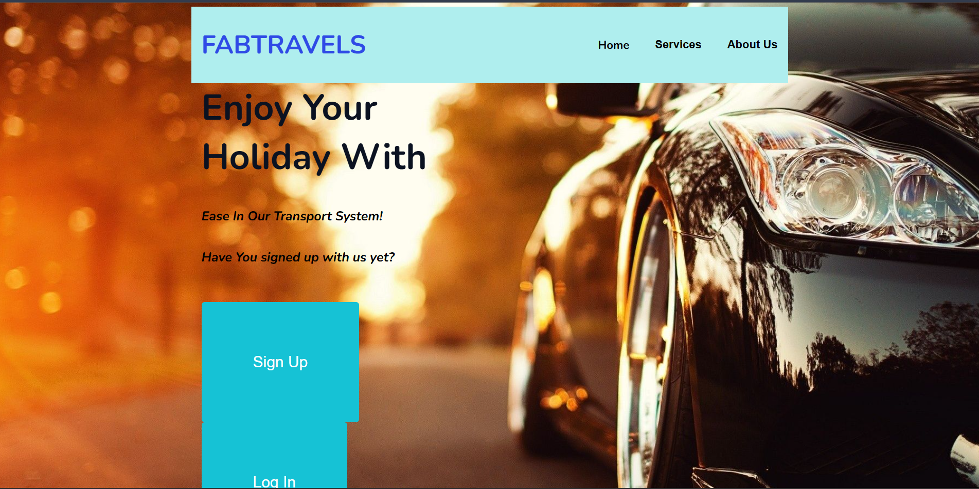

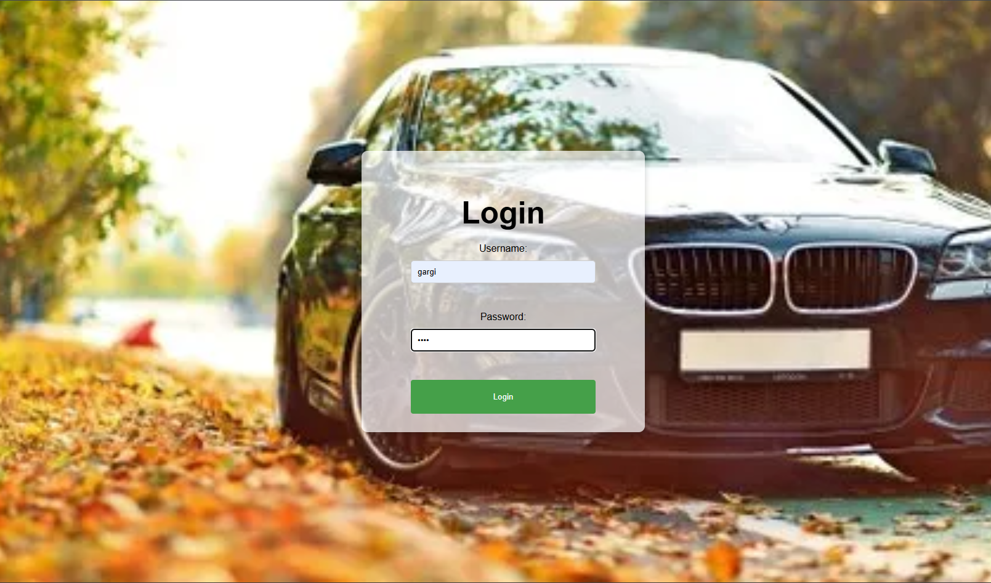

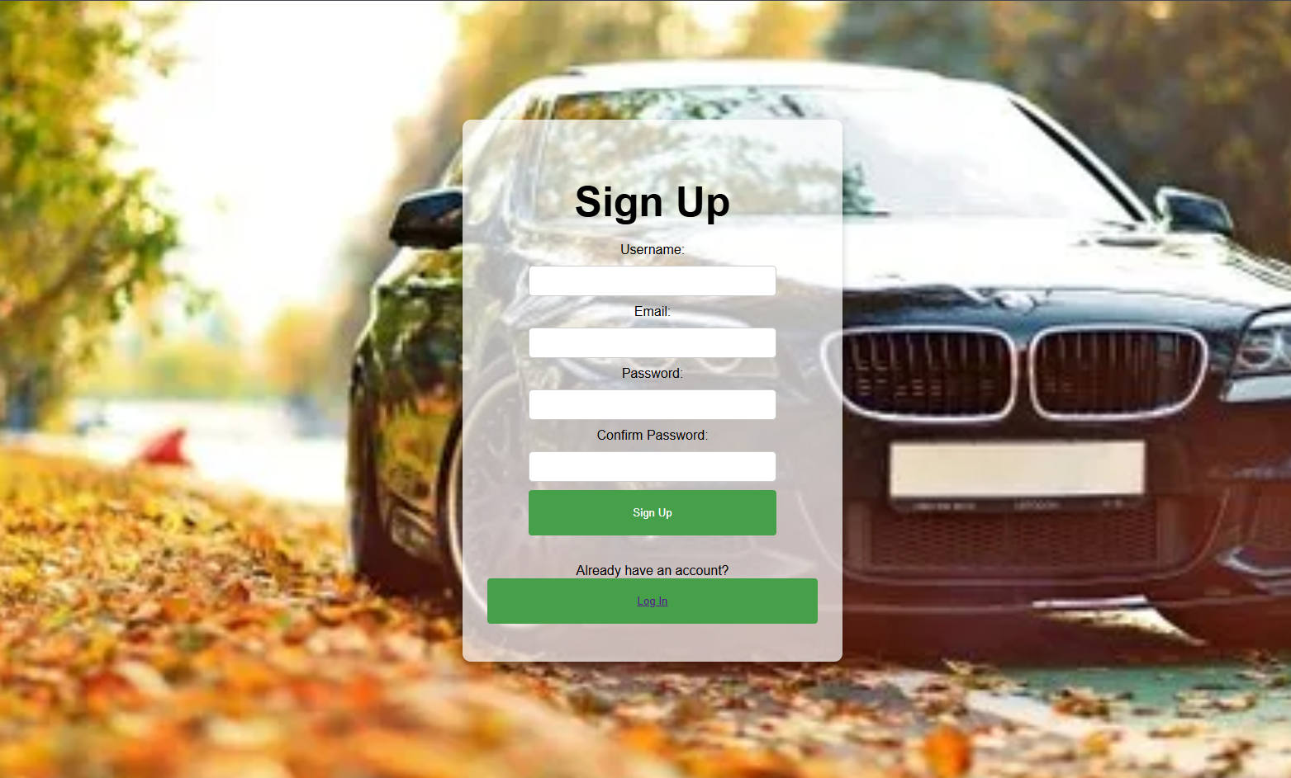



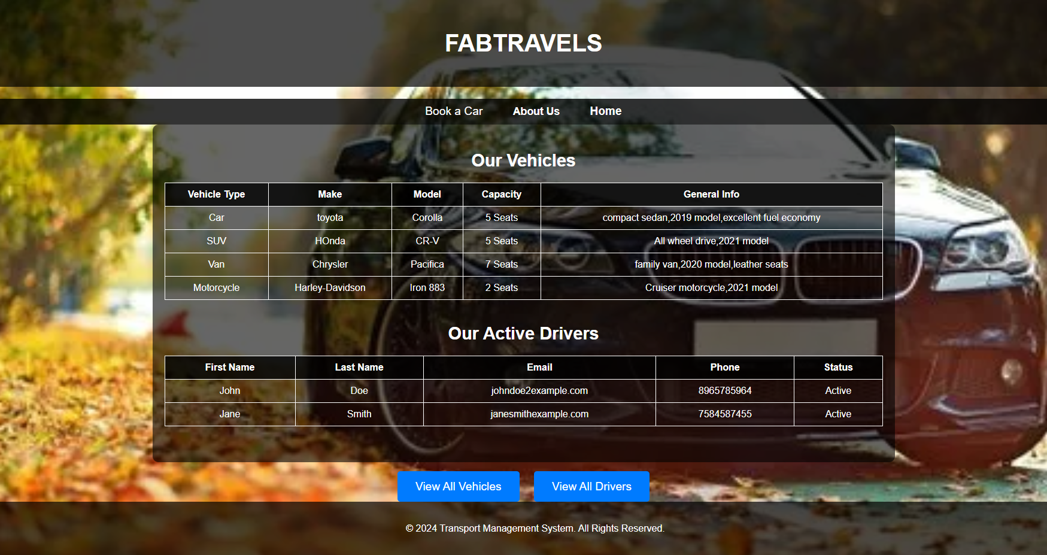



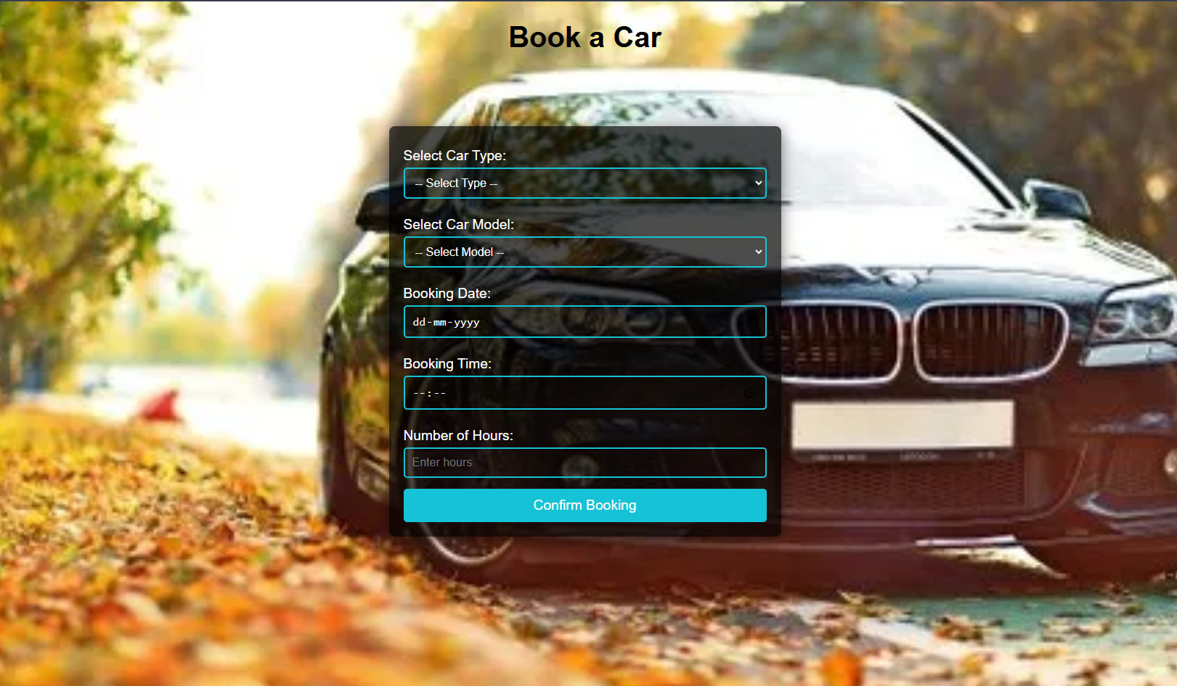

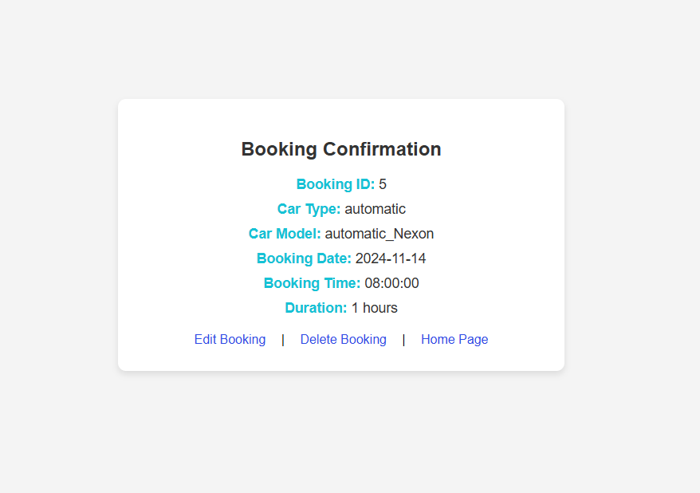

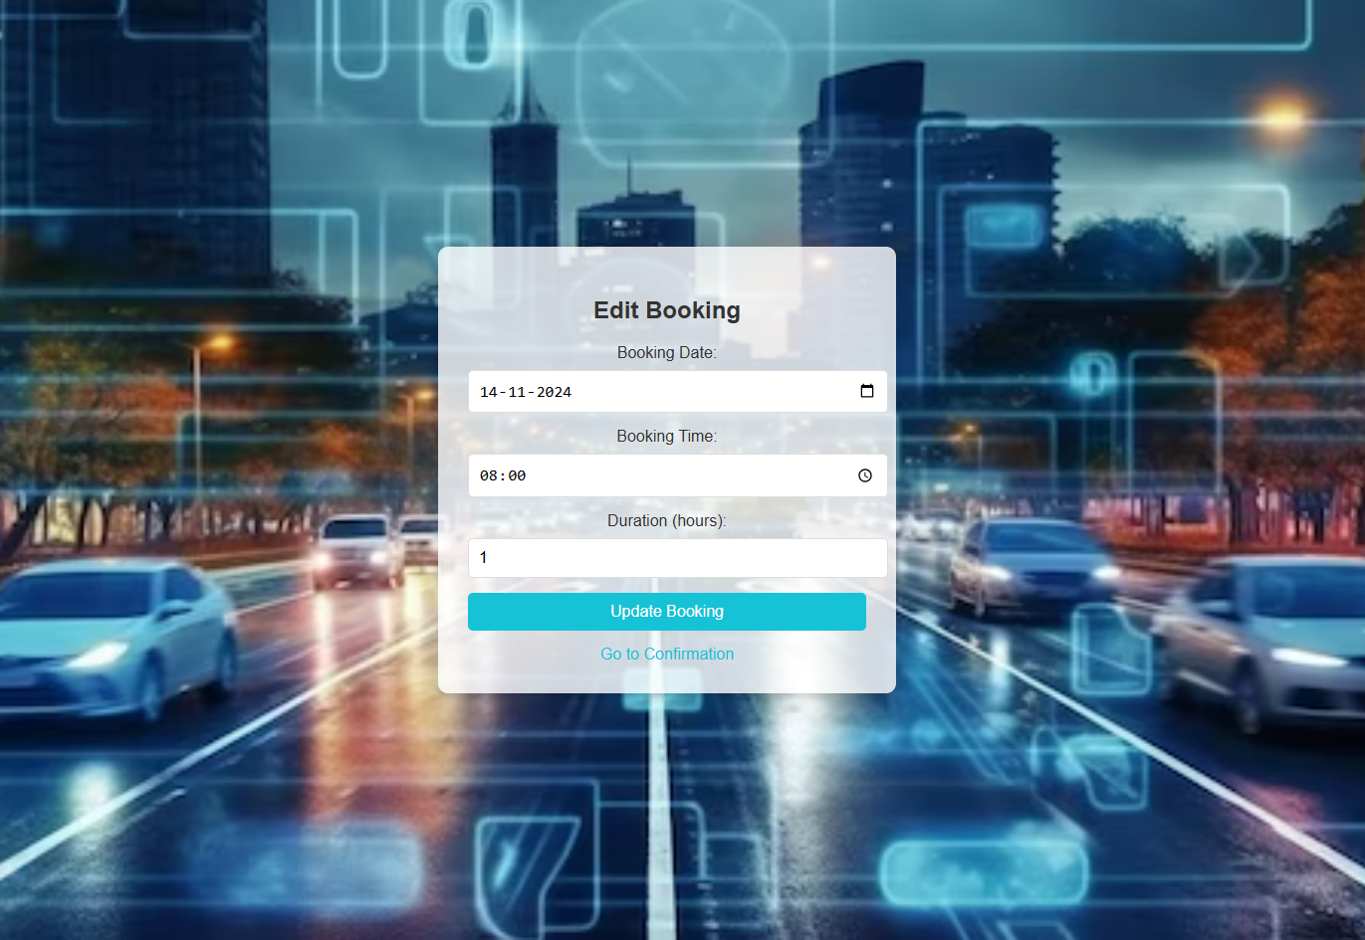

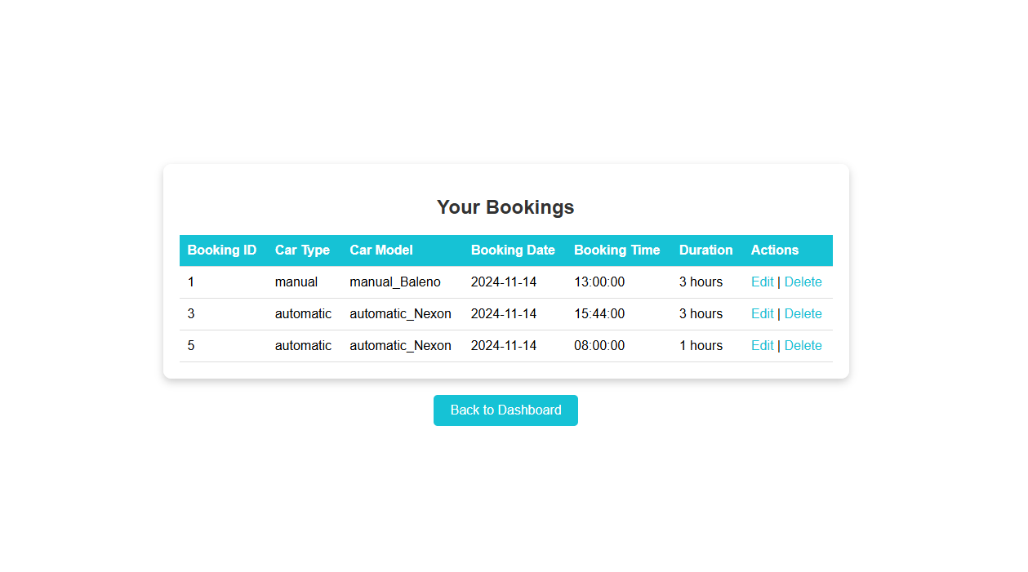

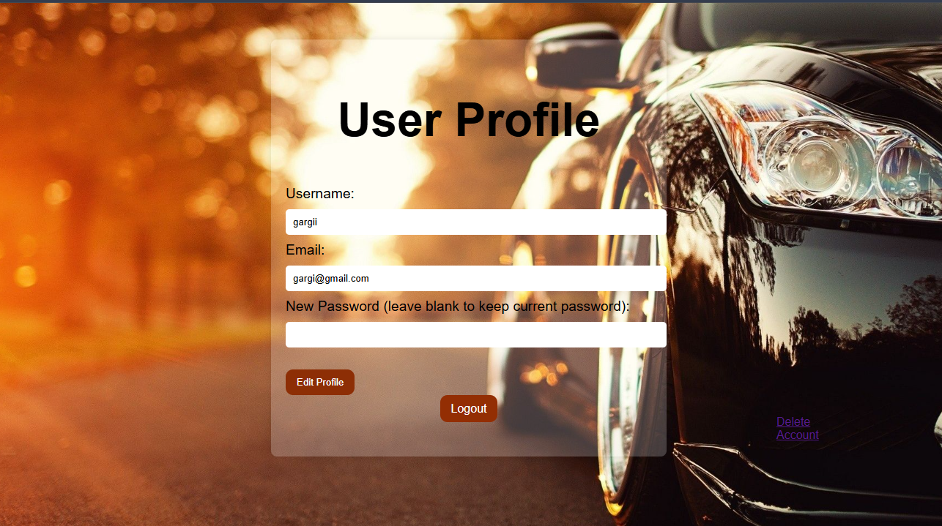

User table

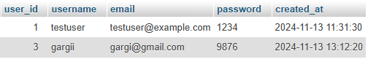

Vehicles table

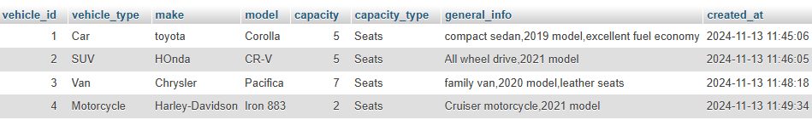

Drivers table

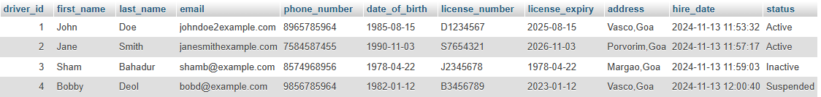

Bookings table

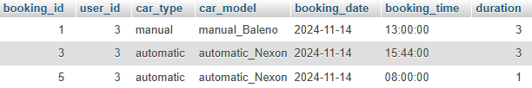

Homepage.php

<?php

session_start();

include 'connection.php';

?>

<!DOCTYPE html>

<html lang="en">

<head>

    <meta charset="UTF-8">

    <meta name="viewport" content="width=device-width, initial-scale=1.0">

    <title>FABTRAVELS</title>

<link rel=”stylesheet” href=”styles.css”>

</head>

<body>

    <div class="container">

        <nav>

            <div class="nav_logo"><b>FABTRAVELS</b></div>

            <ul class="nav_links" id="nav_links">

                <li class="link"><a href="homepage.php"><b>Home</b></a></li>

                <!-- Replace the Services link with a button -->

                <li class="link">

                    <button onclick="window.location.href='services.php';" style="background: none; border: none; color: inherit; font-size: 1.1rem; cursor: pointer; transition: 0.3s;">

                        <b>Services</b>

                    </button>

                </li>

                <!-- Change to button for About Us page -->

                <li class="link">

                    <button onclick="window.location.href='aboutus.php';" style="background: none; border: none; color: inherit; font-size: 1.1rem; cursor: pointer; transition: 0.3s;">

                        <b>About Us</b>

                    </button>

                </li>

                <!-- Conditional "View My Bookings" Button -->

                <?php if (isset($_SESSION['user_id'])): ?>

                    <li class="link">

                        <a href="view_booking.php">

                            <button style="padding: 15px 25px; background-color: orange; color: white; border: none; border-radius: 5px; cursor: pointer;">

                                View My Bookings

                            </button>

                        </a>

                    </li>

                    <li class="link">

                        <a href="book_car.php">

                            <button style="padding: 15px 25px; background-color: orange; color: white; border: none; border-radius: 5px; cursor: pointer;">

                                Book A Car

                            </button>

                        </a>

                    </li>

                    <li class="link">

                        <a href="user_prof.php">

                            <button style="padding: 10px 20px; background-color: orange; color: white; border: none; border-radius: 4px; cursor: pointer;" onclick="location.href='user_prof.php'">

                               Update Profile

                             </button>

                        </a>

                     </li>

                <?php endif; ?>

            </ul>

        </nav>

        <header class="header">

            <div class="content">

                <h1><span><b>Enjoy Your Holiday With</b></span></h1>

                <br>

                <h3><i><b>Ease In Our Transport System!</b></i></h3>

                <h3><i><b>Have You signed up with us yet?</b></i></h3>

                <br/>

                <div class="nav_btns">

                    <?php if (!isset($_SESSION['user_id'])): ?>

                        <!-- Displayed when the user is not logged in -->

                        <button class="btn sign_up" onclick="location.href='signup.php'">Sign Up</button>

                        <button class="btn sign_in" onclick="location.href='login.php'">Log In</button>

                    <?php endif; ?>

                </div>

            </div>

        </header>

    </div>

</body>

</html>

Login.php

<?php

session_start();

include 'connection.php'; // Include your database connection here

if ($_SERVER['REQUEST_METHOD'] === 'POST') {

    $username = $_POST['username'] ?? '';

    $password = $_POST['password'] ?? '';

    if ($username && $password) {

        // Prepare a statement to select user details based on the provided username

        $sql = "SELECT * FROM users WHERE username = ?";

        $stmt = $conn->prepare($sql);

        // Correct parameter binding

        $stmt->bind_param("s", $username);

        // Execute the statement

        $stmt->execute();

        // Get the result

        $result = $stmt->get_result();

        // Check if user exists

        if ($result->num_rows > 0) {

            $user = $result->fetch_assoc();  // Fetch the user details

            // Check if password matches (assuming it's not hashed in this example)

            if ($user['password'] === $password) {

                // Set session variables

                $_SESSION['user_id'] = $user['user_id'];

                $_SESSION['username'] = $user['username'];

                // Redirect to the homepage or another page

                header("Location: homepage.php");

                exit();

            } else {

                $error = "Invalid username or password.";

            }

        } else {

            $error = "Invalid username or password.";

        }

        // Close the statement

        $stmt->close();

    } else {

        $error = "Please fill in both fields.";

    }

}

// Close the database connection

$conn->close();

?>

<!DOCTYPE html>

<html lang="en">

<head>

    <meta charset="UTF-8">

    <title>Login</title>

    <link rel=”stylesheet” href=”styles.css”>

</head>

<body>

<div class="login-container">

    <div class="login-box">

        <h2>Login</h2>

        <?php if (isset($error)) echo "<p class='error-message'>$error</p>"; ?>

        <form method="POST" action="">

            <label for="username">Username:</label>

            <input type="text" id="username" name="username" required>

            <br><br>

            <label for="password">Password:</label>

            <input type="password" id="password" name="password" required>

            <br><br>

            <button type="submit">Login</button>

        </form>

    </div>

</div>

</body>

</html>

Signup.php

<?php

session_start();

include 'connection.php'; // Include your database connection file

if ($_SERVER['REQUEST_METHOD'] === 'POST') {

    $username = $_POST['username'] ?? '';

    $password = $_POST['password'] ?? '';

    $confirmPassword = $_POST['confirm_password'] ?? '';

    $email = $_POST['email'] ?? '';

    $errors = [];

    // Validate input fields

    if (empty($username) || empty($password) || empty($confirmPassword) || empty($email)) {

        $errors[] = "All fields are required.";

    } elseif ($password !== $confirmPassword) {

        $errors[] = "Passwords do not match.";

    } else {

        // Check for existing username or email

        $stmt = $conn->prepare("SELECT * FROM users WHERE username = ? OR email = ?");

        $stmt->bind_param("ss", $username, $email);

        $stmt->execute();

        $result = $stmt->get_result();

        if ($result->num_rows > 0) {

            $errors[] = "Username or email already exists.";

        } else {

            // Insert new user into the users table

            $stmt = $conn->prepare("INSERT INTO users (username, password, email, created_at) VALUES (?, ?, ?, NOW())");

            $stmt->bind_param("sss", $username, $password, $email);

            if ($stmt->execute()) {

                $_SESSION['user_id'] = $conn->insert_id;

                $_SESSION['username'] = $username;

                header("Location: login.php");

                exit();

            } else {

                $errors[] = "Error during signup. Please try again.";

            }

        }

        $stmt->close();

    }

    $conn->close();

}

?>

<!DOCTYPE html>

<html lang="en">

<head>

    <meta charset="UTF-8">

    <meta name="viewport" content="width=device-width, initial-scale=1.0">

    <title>Sign Up</title>

    <link rel=”stylesheet” href=”styles.css”>

</head>

<body>

    <div class="login-container">

        <div class="login-box">

        <h2>Sign Up</h2>

        <?php if (!empty($errors)) {

            foreach ($errors as $error) {

                echo "<p style='color: red;'>$error</p>";

            }

        } ?>

        <form method="POST" action="">

            <label for="username">Username:</label>

            <input type="text" id="username" name="username" required>

            <label for="email">Email:</label>

            <input type="email" id="email" name="email" required>

            <label for="password">Password:</label>

            <input type="password" id="password" name="password" required>

            <label for="confirm_password">Confirm Password:</label>

            <input type="password" id="confirm_password" name="confirm_password" required>

            <button type="submit">Sign Up</button>

        </form>

        <br>

        <p>Already have an account? <button><a href="login.php">Log In</a></button></p>

        </div>

    </div>

</body>

</html>

Book_car.php

<?php

session_start();

include 'connection.php';

// Check if user is logged in

if (!isset($_SESSION['user_id'])) {

    echo "<script>alert('Please log in to book a car.');</script>";

    echo "<script>window.location.href = 'login.php';</script>";

    exit();

}

?>

<!DOCTYPE html>

<html lang="en">

<head>

    <meta charset="UTF-8">

    <title>Book a Car</title>

<link rel=”stylesheet” href=”styles.css”>

</head>

<body>

    <h1>Book a Car</h1>

    <div class="form-container">

        <form id="carBookingForm" action="confirm_booking.php" method="post">

            <!-- User ID - Automatically fetched from session -->

            <input type="hidden" id="userid" name="userid" value="<?php echo $_SESSION['user_id']; ?>">

            <!-- Select Car Type -->

            <label for="carType">Select Car Type:</label>

            <select id="carType" name="carType" onchange="updateCarOptions()" required>

                <option value="">-- Select Type --</option>

                <option value="manual">Manual</option>

                <option value="automatic">Automatic</option>

            </select>

            <!-- Select Car Model Based on Type -->

            <label for="carModel">Select Car Model:</label>

            <select id="carModel" name="carModel" required>

                <option value="">-- Select Model --</option>

            </select>

            <!-- Booking Date -->

            <label for="bookingDate">Booking Date:</label>

            <input type="date" id="bookingDate" name="bookingDate" required>

            <!-- Booking Time -->

            <label for="bookingTime">Booking Time:</label>

            <input type="time" id="bookingTime" name="bookingTime" required>

            <!-- Duration -->

            <label for="duration">Number of Hours:</label>

            <input type="number" id="duration" name="duration" min="1" placeholder="Enter hours" required>

            <!-- Submit Button -->

            <button type="submit">Confirm Booking</button>

        </form>

    </div>

    <script>

        function updateCarOptions() {

            const carType = document.getElementById("carType").value;

            const carModel = document.getElementById("carModel");

            // Clear previous options

            carModel.innerHTML = '<option value="">-- Select Model --</option>';

            // Car options based on the selected type

            const manualCars = [

                { value: 'manual_wagonR', text: 'WagonR' },

                { value: 'manual_Baleno', text: 'Baleno' },

                { value: 'manual_swift', text: 'Swift' }

            ];

            const automaticCars = [

                { value: 'automatic_wagonR', text: 'WagonR' },

                { value: 'automatic_Nexon', text: 'Nexon' },

                { value: 'automatic_Alto', text: 'Alto' }

            ];

            let options = [];

            if (carType === "manual") {

                options = manualCars;

            } else if (carType === "automatic") {

                options = automaticCars;

            }

            options.forEach(option => {

                const opt = document.createElement("option");

                opt.value = option.value;

                opt.textContent = option.text;

                carModel.appendChild(opt);

            });

        }

    </script>

</body>

</html>

Confirm_booking.php

<?php

session_start();

include 'connection.php';

if ($_SERVER['REQUEST_METHOD'] == 'POST') {

// Fetch booking data from the form

$user_id = $_SESSION['user_id'];

$carType = $_POST['carType'];

$carModel = $_POST['carModel'];

$bookingDate = $_POST['bookingDate'];

$bookingTime = $_POST['bookingTime'];

$duration = $_POST['duration'];

// Insert booking data into database

$query = "INSERT INTO bookings (user_id, car_type, car_model, booking_date, booking_time, duration) VALUES (?, ?, ?, ?, ?, ?)";

$stmt = $conn->prepare($query);

$stmt->bind_param("issssi", $user_id, $carType, $carModel, $bookingDate, $bookingTime, $duration);

if ($stmt->execute()) {

$booking_id = $stmt->insert_id;

header("Location: confirmation.php?booking_id=$booking_id");

exit();

} else {

echo "Error: " . $stmt->error;

}

}

?>

Confirmation.php

<!DOCTYPE html>

<html lang="en">

<head>

    <meta charset="UTF-8">

    <meta name="viewport" content="width=device-width, initial-scale=1.0">

    <title>Booking Confirmation</title>

<link rel=”stylesheet” href=”styles.css”>

</head>

<body>

<?php

session_start();

include 'connection.php';

if (isset($_GET['booking_id'])) {

    $booking_id = $_GET['booking_id'];

    // Retrieve booking details

    $query = "SELECT * FROM bookings WHERE booking_id = ?";

    // Prepare the SQL statement

    $stmt = $conn->prepare($query);

    // Check if the query preparation failed

    if ($stmt === false) {

        // Output the actual error message from MySQL

        die("ERROR: Failed to prepare the SQL query. " . $conn->error);

    }

    // Bind the parameter

    $stmt->bind_param("i", $booking_id);

    // Execute the query

    $stmt->execute();

    // Get the result

    $result = $stmt->get_result();

    // Fetch the booking details

    $booking = $result->fetch_assoc();

    if ($booking) {

        // Display the booking confirmation details inside a styled box

        echo "

        <div class='confirmation-box'>

            <h2>Booking Confirmation</h2>

            <p><strong>Booking ID:</strong> " . $booking['booking_id'] . "</p>

            <p><strong>Car Type:</strong> " . $booking['car_type'] . "</p>

            <p><strong>Car Model:</strong> " . $booking['car_model'] . "</p>

            <p><strong>Booking Date:</strong> " . $booking['booking_date'] . "</p>

            <p><strong>Booking Time:</strong> " . $booking['booking_time'] . "</p>

            <p><strong>Duration:</strong> " . $booking['duration'] . " hours</p>

            <div class='actions'>

                <a href='edit_booking.php?booking_id=" . $booking['booking_id'] . "'>Edit Booking</a> |

                <a href='delete_booking.php?booking_id=" . $booking['booking_id'] . "'>Delete Booking</a> |

                <a href='homepage.php'>Home Page</a>

            </div>

        </div>

        ";

    } else {

        echo "<p>Booking not found.</p>";

    }

} else {

    echo "<p>Booking ID not provided.</p>";

}

?>

</body>

</html>

Edit_booking.php

<?php

session_start();

include 'connection.php';

if (isset($_GET['booking_id'])) {

    $booking_id = $_GET['booking_id'];

    // Update booking details

    if ($_SERVER['REQUEST_METHOD'] == 'POST') {

        $bookingDate = $_POST['bookingDate'];

        $bookingTime = $_POST['bookingTime'];

        $duration = $_POST['duration'];

        // Prepare the SQL query

        $query = "UPDATE bookings SET booking_date = ?, booking_time = ?, duration = ? WHERE booking_id = ?";

        $stmt = $conn->prepare($query);

        // Check for errors in query preparation

        if ($stmt === false) {

            die('Error preparing the statement: ' . $conn->error);

        }

        // Bind parameters (check data types and match column types)

        $stmt->bind_param("ssii", $bookingDate, $bookingTime, $duration, $booking_id);

        // Execute the query and handle success/failure

        if ($stmt->execute()) {

            header("Location: confirmation.php?booking_id=$booking_id");

            exit();

        } else {

            echo "Error: " . $stmt->error;

        }

    }

    // Fetch current booking details

    $query = "SELECT * FROM bookings WHERE booking_id = ?";

    $stmt = $conn->prepare($query);

    // Check for errors in query preparation

    if ($stmt === false) {

        die('Error preparing the query: ' . $conn->error);

    }

    $stmt->bind_param("i", $booking_id);

    $stmt->execute();

    $result = $stmt->get_result();

    $booking = $result->fetch_assoc();

}

?>

<!DOCTYPE html>

<html lang="en">

<head>

    <meta charset="UTF-8">

    <meta name="viewport" content="width=device-width, initial-scale=1.0">

    <title>Edit Booking</title>

    <link rel=”stylesheet” href=”styles.css”>

</head>

<body>

<div class="form-container">

    <h2>Edit Booking</h2>

    <form method="post">

        <label for="bookingDate">Booking Date:</label>

        <input type="date" name="bookingDate" value="<?php echo $booking['booking_date']; ?>" required>

        <label for="bookingTime">Booking Time:</label>

        <input type="time" name="bookingTime" value="<?php echo $booking['booking_time']; ?>" required>

        <label for="duration">Duration (hours):</label>

        <input type="number" name="duration" value="<?php echo $booking['duration']; ?>" required>

        <button type="submit">Update Booking</button>

    </form>

    <a href="confirmation.php?booking_id=<?php echo $booking['booking_id']; ?>">Go to Confirmation</a>

</div>

</body>

</html>

Delete_booking.php

<?php

session_start();

include 'connection.php';

if (isset($_GET['booking_id'])) {

    $booking_id = $_GET['booking_id'];

    $query = "DELETE FROM bookings WHERE booking_id = ?";

    $stmt = $conn->prepare($query);

    $stmt->bind_param("i", $booking_id);

    if ($stmt->execute()) {

        echo "<script>alert('Booking deleted successfully.');</script>";

        echo "<script>window.location.href = 'book_car.php';</script>";

    } else {

        echo "Error: " . $stmt->error;

    }

}

?>

User_prof.php

<?php

session_start();

include 'connection.php';

// Redirect to login if the user is not logged in

if (!isset($_SESSION['user_id'])) {

    header("Location: login.php");

    exit();

}

// Fetch the current user details

$userId = $_SESSION['user_id'];

$sql = "SELECT user_id, username, email, password FROM users WHERE user_id = ?";

// Check if the SQL statement is prepared correctly

$stmt = $conn->prepare($sql);

if ($stmt === false) {

    // Display the error message if prepare() fails

    echo "Error preparing the SQL statement: " . $conn->error;

    exit();

}

$stmt->bind_param("i", $userId);

$stmt->execute();

$result = $stmt->get_result();

// Check if the user exists

if ($result->num_rows === 0) {

    echo "No user found with the provided ID.";

    exit();

}

$user = $result->fetch_assoc();

if ($_SERVER['REQUEST_METHOD'] === 'POST') {

    $username = $_POST['username'];

    $email = $_POST['email'];

    $password = $_POST['password'] ? password_hash($_POST['password'], PASSWORD_DEFAULT) : $user['password'];

    // Update user details in the database

    $updateSql = "UPDATE users SET username = ?, email = ?, password = ? WHERE user_id = ?";

    $updateStmt = $conn->prepare($updateSql);

    if ($updateStmt === false) {

        echo "Error preparing the update SQL statement: " . $conn->error;

        exit();

    }

    $updateStmt->bind_param("sssi", $username, $email, $password, $userId);

    if ($updateStmt->execute()) {

        // Update the session username

        $_SESSION['username'] = $username;

        echo "<p>Profile updated successfully!</p>";

    } else {

        echo "<p>Error updating profile. Please try again.</p>";

    }

}

?>

<!DOCTYPE html>

<html lang="en">

<head>

    <meta charset="UTF-8">

    <meta name="viewport" content="width=device-width, initial-scale=1.0">

    <title>Update Profile</title>

    <link rel="stylesheet" href="user_prof.css">

</head>

<body>

    <div class="container">

        <h2>User Profile</h2>

        <form method="POST">

            <label for="username">Username:</label>

            <input type="text" id="username" name="username" value="<?php echo htmlspecialchars($user['username']); ?>" readonly required>

            <label for="email">Email:</label>

            <input type="email" id="email" name="email" value="<?php echo htmlspecialchars($user['email']); ?>" readonly required>

            <label for="password">New Password (leave blank to keep current password):</label>

            <input type="password" id="password" name="password" readonly>

            <div class="buttons">

                <button type="submit" id="saveButton" style="display:none;">Save Changes</button>

                <button type="button" id="editButton">Edit Profile</button>

            </div>

            <div class="logout">

                <a href="logout.php" class="logout-button">Logout</a>

            </div>

            <div class="delete">

                <a href="delete.php" class="delete-button">Delete Account</a>

            </div>

        </form>

    </div>

    <script>

        document.getElementById('editButton').addEventListener('click', function () {

            // Enable the fields for editing

            document.querySelectorAll('input').forEach(input => input.removeAttribute('readonly'));

            // Show the save button and hide the edit button

            document.getElementById('saveButton').style.display = 'inline-block';

            document.getElementById('editButton').style.display = 'none';

        });

    </script>

</body>

</html>

Delete.php

<?php

session_start();

include 'connection.php';

// Ensure the user is logged in before deleting their account

if (!isset($_SESSION['user_id'])) {

    header("Location: login.php");

    exit();

}

// Get the current user's ID

$userId = $_SESSION['user_id'];

// Prepare the SQL query to delete the user from the database

$sql = "DELETE FROM users WHERE user_id = ?";

$stmt = $conn->prepare($sql);

if ($stmt === false) {

    // If there is a problem with preparing the statement, show an error

    echo "Error preparing the SQL statement: " . $conn->error;

    exit();

}

// Bind the user ID to the query

$stmt->bind_param("i", $userId);

// Execute the delete query

if ($stmt->execute()) {

    // If successful, destroy the session and log the user out

    session_unset();

    session_destroy();

    // Redirect the user to the homepage or login page

    header("Location: homepage.php");  // You can change this to your preferred page

    exit();

} else {

    // If there was an error deleting the account, show an error message

    echo "Error deleting account. Please try again.";

}

$stmt->close();

$conn->close();

?>

Logout.php

<?php

session_start();

// Destroy the session to log the user out

session_unset();

session_destroy();

// Redirect the user to the login page

header("Location: login.php");

exit();

?>

View_booking.php

<?php

session_start();

include 'connection.php';

// Check if user is logged in

if (!isset($_SESSION['user_id'])) {

    header("Location: login.php");

    exit();

}

$user_id = $_SESSION['user_id'];

// Fetch bookings for the logged-in user

$query = "SELECT * FROM bookings WHERE user_id = ? ORDER BY booking_date DESC";

$stmt = $conn->prepare($query);

// Check for errors in query preparation

if ($stmt === false) {

    die('Error preparing the statement: ' . $conn->error);

}

$stmt->bind_param("i", $user_id);

$stmt->execute();

$result = $stmt->get_result();

// Check if there are any bookings

if ($result->num_rows > 0) {

    $bookings = $result->fetch_all(MYSQLI_ASSOC);

} else {

    $bookings = [];

}

?>

<!DOCTYPE html>

<html lang="en">

<head>

    <meta charset="UTF-8">

    <meta name="viewport" content="width=device-width, initial-scale=1.0">

    <title>My Bookings</title>

<link rel=”stylesheet” href=”styles.css”>

</head>

<body>

<div class="container">

    <div class="booking-box">

        <h2>Your Bookings</h2>

        <?php if (!empty($bookings)) { ?>

            <table class="booking-list">

                <thead>

                    <tr>

                        <th>Booking ID</th>

                        <th>Car Type</th>

                        <th>Car Model</th>

                        <th>Booking Date</th>

                        <th>Booking Time</th>

                        <th>Duration</th>

                        <th>Actions</th>

                    </tr>

                </thead>

                <tbody>

                    <?php foreach ($bookings as $booking) { ?>

                        <tr>

                            <td><?php echo $booking['booking_id']; ?></td>

                            <td><?php echo $booking['car_type']; ?></td>

                            <td><?php echo $booking['car_model']; ?></td>

                            <td><?php echo $booking['booking_date']; ?></td>

                            <td><?php echo $booking['booking_time']; ?></td>

                            <td><?php echo $booking['duration']; ?> hours</td>

                            <td>

                                <a href="edit_booking.php?booking_id=<?php echo $booking['booking_id']; ?>">Edit</a> |

                                <a href="delete_booking.php?booking_id=<?php echo $booking['booking_id']; ?>">Delete</a>

                            </td>

                        </tr>

                    <?php } ?>

                </tbody>

            </table>

        <?php } else { ?>

            <p>You have no bookings yet.</p>

        <?php } ?>

    </div>

    <a href="homepage.php" class="back-btn">Back to Dashboard</a>

</div>

</body>

</html>